Name: _______________________________________ Hour: _______
The Epic of Gilgamesh Reading Questions –Sumerian Mythology (35 points)
Questions: Answer using complete sentences and specific details.
Chapter 1 (Pg. 174-177):
- Based on the prologue, what can readers expect Gilgamesh to discover throughout the epic?

- How would you describe the political organization of Uruk?
2. What kind of king is Gilgamesh? What does the description of “two-thirds god” reveal about Gilgamesh?
- What fate is Gilgamesh destined to share with all human beings? How does he feel about his fate?

- Why and how is Enkidu created? How does he differ from Gilgamesh?

- What does Enkidu learn from the priestess? How do the animals treat the newly transformed Enkidu?

Chapter 2 (Pg. 177-180):

- How does Enkidu imagine he will win Gilgamesh's respect?

- What steps does Enkidu take to become “civilized”?

- Which gods are in favor of Gilgamesh?

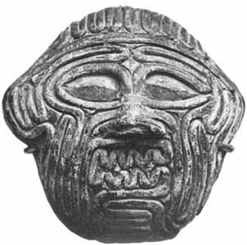
- How does Gilgamesh know Enkidu will arrive in Uruk?

- How does the battle between Gilgamesh and Enkidu end?

Chapter 3 (Pg. 180-184):
- Why do Enkidu and Gilgamesh go to the Cedar Forest of Lebanon?

- Name and describe the being that rules over the forest. Why does Gilgamesh want to fight this monster?

- To what deity does Gilgamesh make an offering? What does this deity agree to do? Why does he/she agree to do it?

Chapter 4 (Pg. 184-187):
34. How does Shamash aid Gilgamesh and Enkidu?
- How are the roles of Gilgamesh and Enkidu reversed in this chapter?

- Explain whether or not you agree with the killing of Humbaba. Give reasons to support your opinion.

Chapter 5 (Pg. 187-191):
- Why doesn’t Gilgamesh want to marry Ishtar?

- What does the goddess want sent down to Uruk to punish Gilgamesh? Who thrusts a sword into this creature?

- How does Enkidu insult the goddess? What is Enkidu’s punishment?

- Going beyond the fact that Enkidu and Gilgamesh are friends, why is Gilgamesh so affected by what happens to Enkidu?
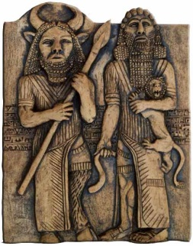
Chapter 6 (Pg. 191-196):
- Why does Gilgamesh search for Utanapishtim?

- What timeless advice does Siduri give to Gilgamesh?

- Why is Gilgamesh supposed to see Urshanabi? How does Gilgamesh anger Urshanabi?

- According to Utanapishtim, what is permanent in life?

- Who, according to Utanapishtim, decrees the fate of each human being? What should Gilgamesh learn from this message?

Chapter 7 (Pg. 196-200):
- According to Utanapishtim, why does the great flood take place?

- Which god did not support the idea of the flood?

- What was Utanapishtim told to build?

- On what mountain did the ship come to rest?

- Who made Utanapishtim and his wife immortal? Why were they made immortal?

Chapter 8 (200-203):

- What gifts have been given to Gilgamesh by the gods, according to Utanapishtim?

- What gift does Utanapishtim direct Gilgamesh to gather? What happens to the gift?

- What does Gilgamesh realize when he returns to Uruk?

- Did Gilgamesh change at all in the course of this epic? If so, how?

- What kind of hero is Gilgamesh? How does he compare to other heroes, such as Achilles, Odysseus, and Aeneas?

- What roles do women play in the epic? What do their representations suggest about the significance of women in this ancient culture?

