Letter to Ms. Juzwik
Your task is to write a letter to Ms. Juzwik so she can evaluate your writing ability and also get to know about your goals in the class and plans for the future.
Your letter should include:
- Your writing background (classes, workshops, specialties, struggles)
- Why did you elect to take this course? (Recommendation? If so, by whom?)
- Your goals in College Prep Writing (What do you want to get out of it?)
- Your plans for the future (University? Major/minor?)
- Your interests, passions, hobbies
- How have you changed since freshman year?
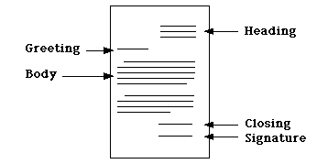
- Any information you feel Ms. Juzwik needs to know about your learning styles and accommodations
This letter should be written in friendly-letter format. It will be 1.5-2 pages typed, printed off and turned in.
*You may use your name and the high school’s address for your heading
(Mount Horeb High School, 305 South 8th Street, Mount Horeb, WI 53572)

*You do not need to sign the document; your typed name will be sufficient.

While writing your letter, consider the following writing traits:
- Ideas: the main message;
- Organization: the internal structure of the piece;
- Voice: the personal tone of the writer’s message;
- Word Choice: the appropriate vocabulary a writer chooses to convey meaning;
- Sentence Fluency: the rhythm and flow of the language;
- Conventions: the mechanical correctness; and
- Presentation: how the writing/ formatting looks on the page.

I will grade this assignment (and this assignment only) on completion. However, you are expected to put in just as much effort as you would for any other assignment. Your letter will help determine what you learn in the class, so if you don’t want to spend two weeks on sentence fragments, make sure your letter has none.

