“Article of the Week” Instructions

About every week you will be given an "Article of the Week" which you will read in class and then upload your response to our online discussion forum. This is a typical writing assignment which you will encounter in college.
Requirements: Articles for the week will be given out on the first day of class each week (typically Monday). We will spend some time in class reading and annotating (see below) our articles. For full credit on this assignment you will need to upload your response to
1. Your responses must be written in organized, complete sentences with proper mechanics and clear ideas. Use only third person point of view. There should be no “I” or “you” anywhere in your entries.
2. You may use the topic provided on the article as your starting point, or you may choose to create your own writing topic.
3. You must stay on topic and follow the discussion in your responses. Each response must reference and attribute points made in the article, whether you’re supporting or refuting them.

The following is a list of some techniques that you can use to annotate text:
- Underline important terms and definitions.
- Circle words or concepts you don’t yet know.
- Write questions you have in the margin.
- Write key words and definitions in the margin.
- Signal where important information can be found with key words or symbols in the margin.
- Write short summaries in the margin at the end of sub-units.
- Write the questions in the margin next to the section where the answer is found.
- Indicate steps in a process by using numbers in the margin.
*Over the next few weeks, you will be learning how to identify and analyze the following, as part of your annotations: persuasive appeals, rhetorical devices, diction, tone and syntax.

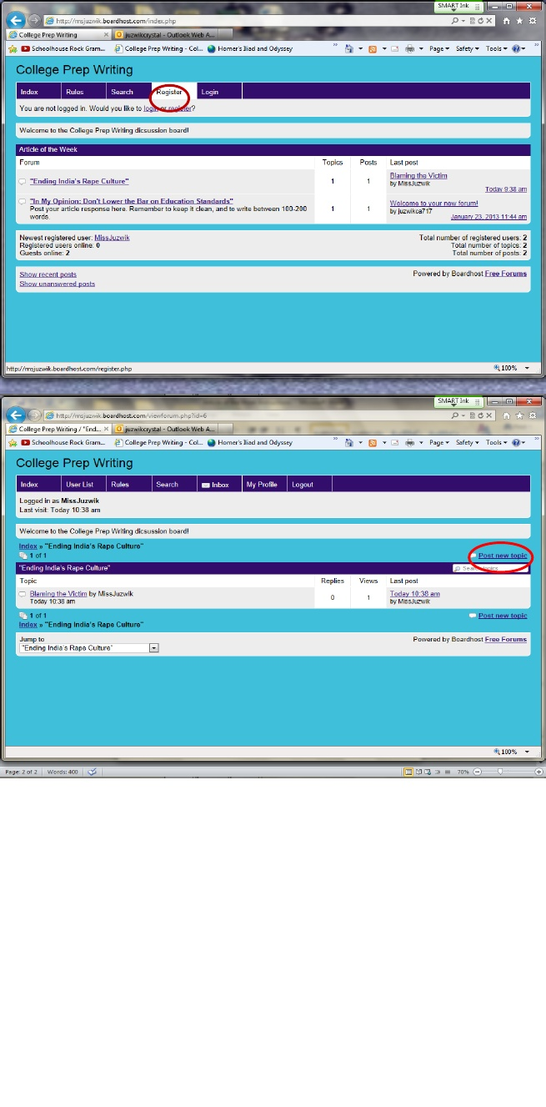
1) Register for the forum
2) Post a “New Topic”: this is where you’ll be posting your thoughts on the discussion topic of the week. This is your expressed opinion, citing evidence from the sources we’ve read to strengthen your argument.
3) Read one another’s posts and engage in an academic discourse, by responding to one another’s writing.

To reply to another person’s comment, click “Post reply” once you’ve read the comment.

