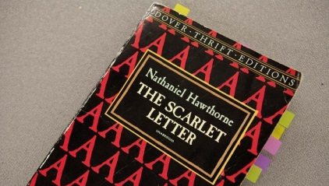
Copy of 'The Scarlet Letter' Can't Believe the Notes High Schooler Writes In Margins

The paperback book says it is astonished by how “completely off” Dobson’s margin notes have been.

FOX CHAPEL, PA—A mass-market paperback edition of The Scarlet Letter confirmed Wednesday that it simply could not believe the misguided and often completely erroneous notes that local high school sophomore Phoebe Dobson has been writing in its margins.
The copy of Nathaniel Hawthorne’s classic 1850 novel, which explores notions of sin and guilt against the backdrop of Puritan Boston in the 17th century, expressed surprise over the rampant spelling and grammar errors in the 16-year-old’s handwritten comments, as well as her tenuous grasp of its relatively straightforward plot.
“Right from chapter one I could tell this was going to be rough,” said the 192-page book, citing Dobson’s speculation in the margin that in addition to “adulteress,” the scarlet “A” worn by the novel’s main character, Hester Prynne, might stand for “America.” “At that point I thought, ‘Oh, boy, here we go.’ And then she wrote ‘red = success.’ I mean, good lord. How could that even begin to make sense?”
“I should have known something was wrong when she highlighted the entire first page,” the book added, explaining that Dobson had used fluorescent Bic Brite Liners to flag numerous unimportant passages, presumably for future reference. “Maybe she just likes using those markers or something, because the unhighlighted words are pretty much in the minority at this point.”

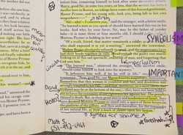
Baffled that the young reader for some reason circled the word “cottage” every time she came across it in the text, the used copy of The Scarlet Letter stated that it truly began to doubt Dobson’s reading-comprehension skills when she wrote a note on page 37 suggesting the entire novel might in fact be an allegory for the Civil War.
The book also confirmed that Dobson appeared to believe the novel’s mysterious “Black Man,” a shadowy figure Hawthorne uses to represent evil, was “just some random black guy who keeps showing up.”
“How can you possibly misidentify the chief antagonist in this story? He’s a bitter, hunched-over old man named Chillingworth, for God’s sake,” said the book, adding that the high school student wrongly suspected the father of Prynne’s child to be a peripheral town elder who had appeared only once in the novel’s first 60 pages. “How much more of a tip-off do you need? This stuff is pretty cut and dried.”
Other markings made by Dobson in the book have reportedly included the penciling of the name Adam DePalma (who is not a character in the novel) 86 times inside the back cover, a note mistakenly referring to the author of the book as Hemingway, a doodle of a three-dimensional square, a beverage-condensation ring on the front that has since collected hair and dust, a misspelled query that simply reads “symbalism?” and an application of nail polish to the about-the-author page that was apparently used to compare slightly differing shades of burgundy.
According to the paperback, its hopes for Dobson getting anything at all out of the novel were permanently dashed after she reached a pivotal moment in the story when a celestial “A” appears in the sky during a meteor shower.
“That’s when I knew she had completely checked out,” the book said. “I thought, ‘This is as clear-cut as it gets—she can’t possibly miss this.’ Then she lifts her pencil and I’m getting my hopes up, but what does she do with it? Draws a goddamn flower. Another one. There have been at least a dozen, and she’s only on page 105.”
“I hope she fucking burns me when she’s done,” the book added.
- Who is the target of this satire?
- What do they represent in the larger societal context?
- What method of satire is being employed in this article?
- What mode is most likely being used and why?
- What category of satire would this fall under: Juvenalian or Horacian?
- What is the author’s purpose in writing this article? What goal did they hope to achieve?

