Headings and Subheadings
Break down your topics to create headings and subheadings which will help guide your reader through the paper.
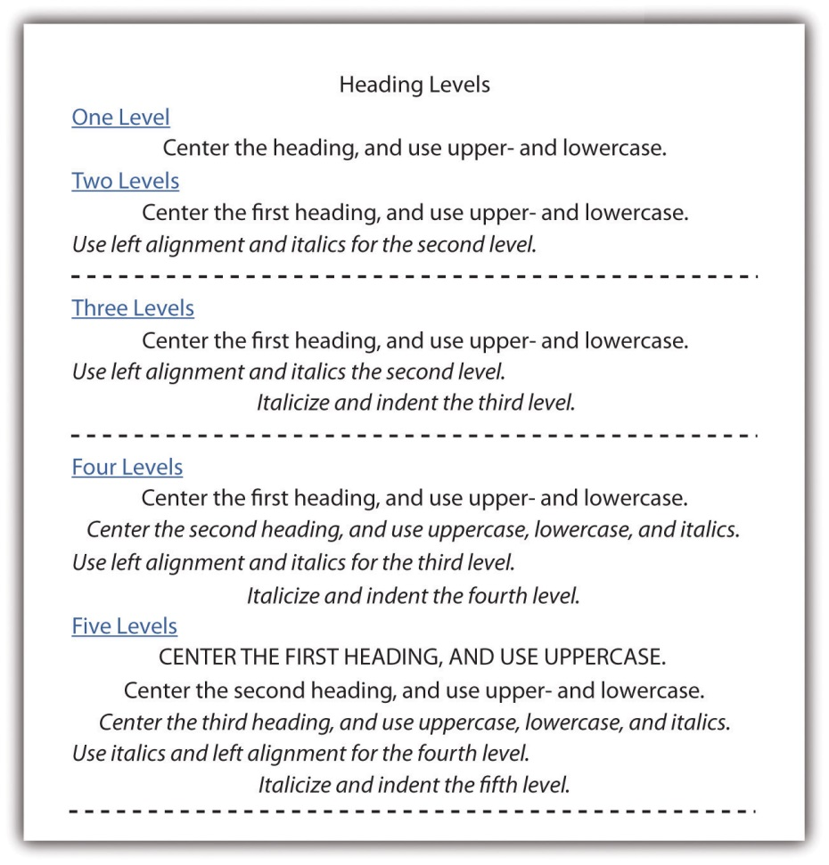
APA Format Example (Three Levels)
(Topic: Causes for Divorce)
I. Age Factors
-------------------------------------------
-----------------------------------------------------
1.1 Marriage at a Young Age
-------------------------------------------
-----------------------------------------------------
1.1.1 Emotional Immaturity
-------------------------------------------
-----------------------------------------------------
1.1.2 Changing Interests
-------------------------------------------
-----------------------------------------------------
1.2 Finances
-------------------------------------------
-----------------------------------------------------

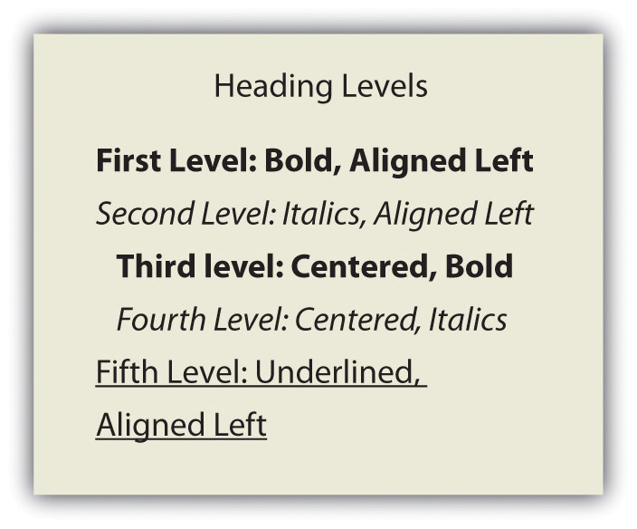
MLA Format Example (Three Levels)
(Topic: Causes for Divorce)
I. Age Factors
-------------------------------------------
-----------------------------------------------------
1.1 Marriage at a Young Age
-------------------------------------------
-----------------------------------------------------
1.1.1 Emotional Immaturity
-------------------------------------------
-----------------------------------------------------
1.1.2 Changing Interests
-------------------------------------------
-----------------------------------------------------
1.2 Finances
-------------------------------------------
-----------------------------------------------------

Outline (30 points)
As you gather research to support your thesis statement, work on developing an outline which will help you to organize your thoughts before drafting. Follow the example template below to write your outline, using headings and subheadings. You may be brief, but include enough information to make sense. Submit to Turnitin.com by due date.
MLA Example
Introduction (One complete paragraph in essay; no heading in actual essay)
Hook:
Context:
Thesis:

I. Heading (Indicate topic; Number of subheadings will vary)
1.1 Subheading
1.1.1 Subheading
1.2 Subheading
1.2.1 Subheading
1.2.2 Subheading

II. Heading
2.1 Subheading
2.1.1 Subheading
2.1.2 Subheading
2.2 Subheading

III. Heading
3.1 Subheading
3.2 Subheading
3.3 Subheading

Conclusion

